**Legends of RedJak’s Automated Imperial (LORAI)**

**Concept Paper**

## Required features

* Create a deployment hand based on threat level, mission, and various other options.
* Manage Imperial activations: Choose which groups to activate, what bonus effects to apply and which Rebel to target.
* Manage threat and deployment: Increase threat, deploy groups based on different deployment behaviors, reinforce groups.
* Randomization: Randomize deployment behavior, targeted hero, bonus effect, instruction, event display.
* Make it possible for me to edit and finetune various things, such as mission rules/mission info, events, bonus effects, instructions, probabilities etc. (either via some sort of back-end or clear and easy-to-understand code / code with enough notations)

## Nice-to-have feature

* Make it possible for players to add their own groups, missions, and events.

Table of Contents

Required features 1

Nice-to-have feature 1

Wireframes: Mission Selection / Options 2

Wireframes: Main Screen 3

Wireframes: Main Screen – Mission Info 4

Wireframes: Main Screen – Deployment 4

Wireframes: Main Screen – Enemy Activation 5

Wireframes: Main Screen – Events 6

Difficulty options 7

Creating the deployment hand 7

Deployment rules 7

Fuzzy deployment 8

Manual Deployment 8

Custom Deployment Group 8

Imperial Activations 8

Activation Priority (Optional) 9

Random Elements 9

Manual activations 9

## Wireframes: Mission Selection / Options

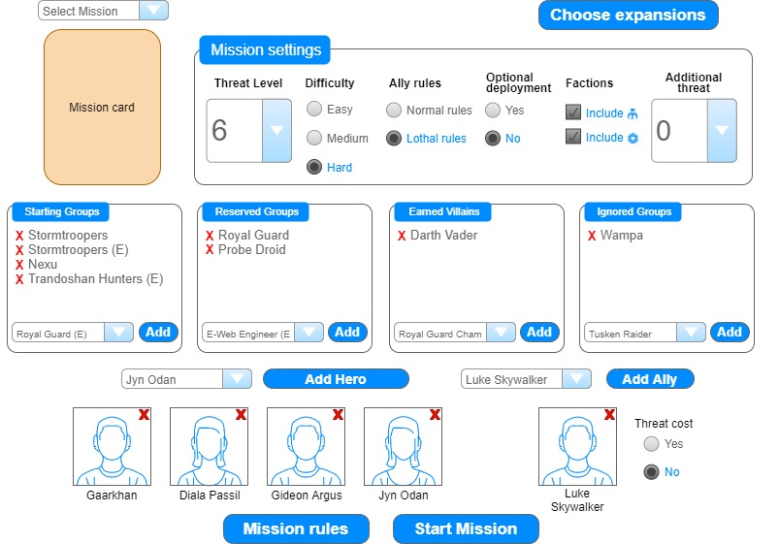This is the screen displayed when the app is started. You can choose which expansions to use in the top right. Expansions determine the availability of some groups.

1. The mission selection. If a mission is selected, it shows the mission card (from boardwars.eu.)
2. Select the Threat Level.
3. Select the Difficulty. (Easy = lower threat, Medium = normal, High = higher threat)
4. Select whether to use the normal ally rules or the alternative rule from Tyrants of Lothal.
5. If “Yes” is chosen, at the start of the mission, the app increases threat by twice the threat level and resolves an optional deployment. (Like in every side mission.)
6. Some missions demand you use only groups from a certain faction. Use this to tell the app what factions to use.
7. “Additional threat” increases threat by the amount entered at the start of the mission. Do this to make things harder.
8. Select the starting groups of the mission. Starting groups are removed from the deck of available groups to make sure the app doesn’t deploy too many groups of the same type. Click the X to remove a group from the list.
9. Select the reserved groups for the same reason.
10. Select earned villains. They are added to the available groups.
11. Select ignored groups. Those groups are never employed by the app. You can only deploy them manually (see “main screen”). Do this, for example, to eliminate groups unfitting for the map (like Wampas in a desert mission).
12. Choose the heroes you want to use. Click the X to remove a hero.
13. Choose an ally you want to take with you.
14. Choose whether the ally is free or has a threat cost. If it has a threat cost, at the start of the mission, the app increases the threat by the respective cost and performs an optional deployment.
15. Click to display any special mission rules.
16. Start the mission.

## Wireframes: Main Screen

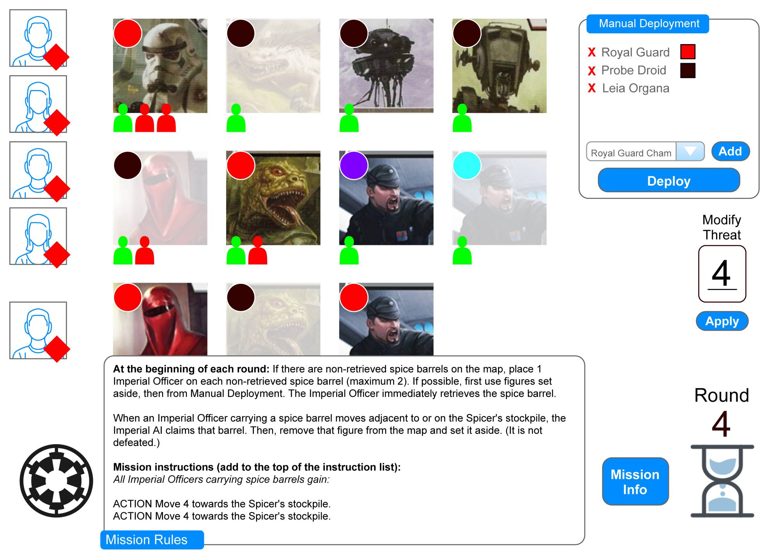This is the main screen of the app.

1. These are the heroes and (at the bottom) any allies. Click on the red square to mark a hero as Wounded. (The app focuses on healthy heroes.)
2. All deployed enemy groups are listed here. If an enemy is not exhausted, you can activate it by manually clicking on it and selecting “Activate”. However, this is usually not necessary – the app activates enemies automatically.
   1. In the top left corner, you can choose to apply a color to the group.
   2. At the bottom, the app displays the number of figures in a group. Click on a green figure to defeat it. Click on a red figure to reinforce it. If all figures are defeated, the whole group is defeated.
3. Use this list to manually deploy units, for example reserved units when a mission event tells you to. You can also use this to deploy allies during a mission. Manual deployment does not affect threat. If you want to manually deploy units and subtract threat from the total, use “Modify threat”.
4. Use this to manually add or subtract threat, for example when a mission event tells you to.
5. Click here to activate the next Imperial group. The app randomly chooses which figure to activate and displays the group’s bonus effects and instructions. Afterwards, the group is exhausted.
6. If there are any special mission rules, they are permanently displayed at the bottom. Ideally, you can click the “Mission rules” button to minimize the window so there is more space for deployment groups.
7. Click here to view general information about the mission (see next page).
8. Once all figures have been activated, click here to advance to the next round. The app increases the round timer, increases threat, deploys new groups and may display an event. Then the next round starts.

## Wireframes: Main Screen – Mission Info

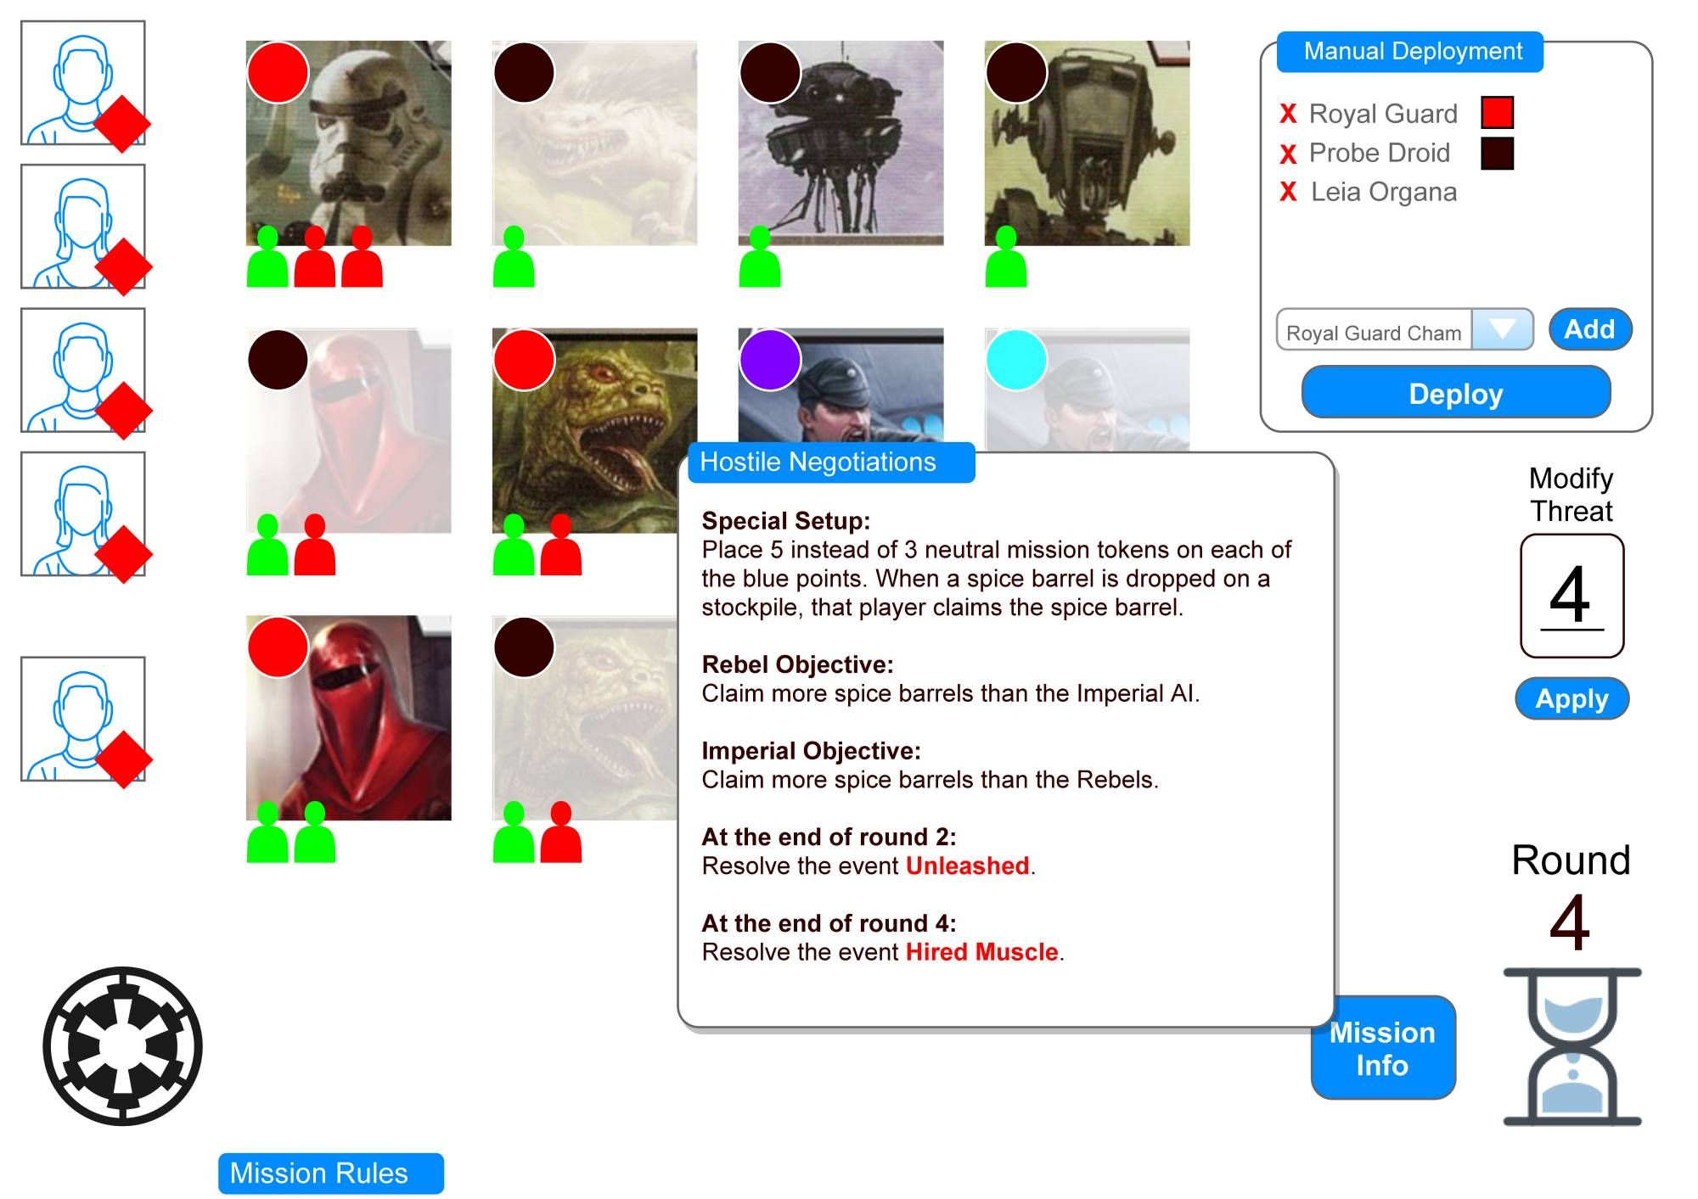

## Wireframes: Main Screen – Deployment

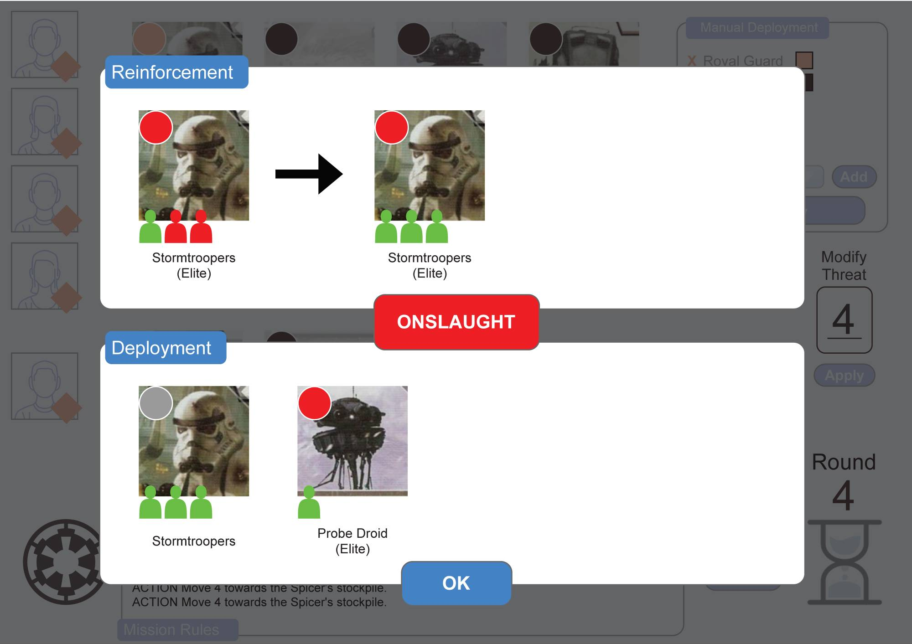

At the beginning of each round, the app tells you which units to deploy. Which units are deployed is determined by one of four deployment events: **Calm**, **Reinforcements**, **Landing** and **Onslaught**.

## Wireframes: Main Screen – Enemy Activation

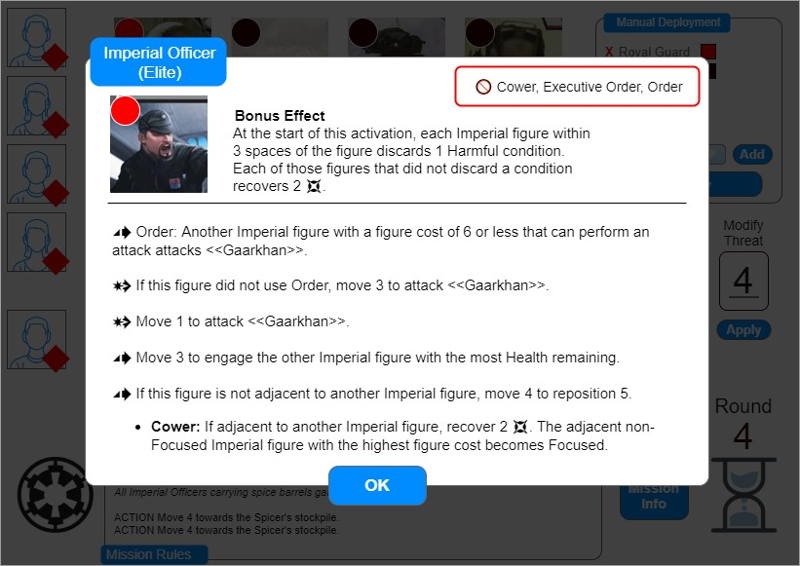

1. This shows the enemy unit to activate and its color.
2. When activating a group, the app randomly chooses one of up to 6 bonus effects.
3. This entry tells players which abilities on the deployment card to ignore.
4. This is the instruction list.
5. The app randomly targets one of the healthy heroes.
6. Some figures have multiple options for instructions. (For example, General Weiss has multiple options for which colors to use in an attack.) The app randomly chooses one and displays only the chosen part.

## Wireframes: Main Screen – Events

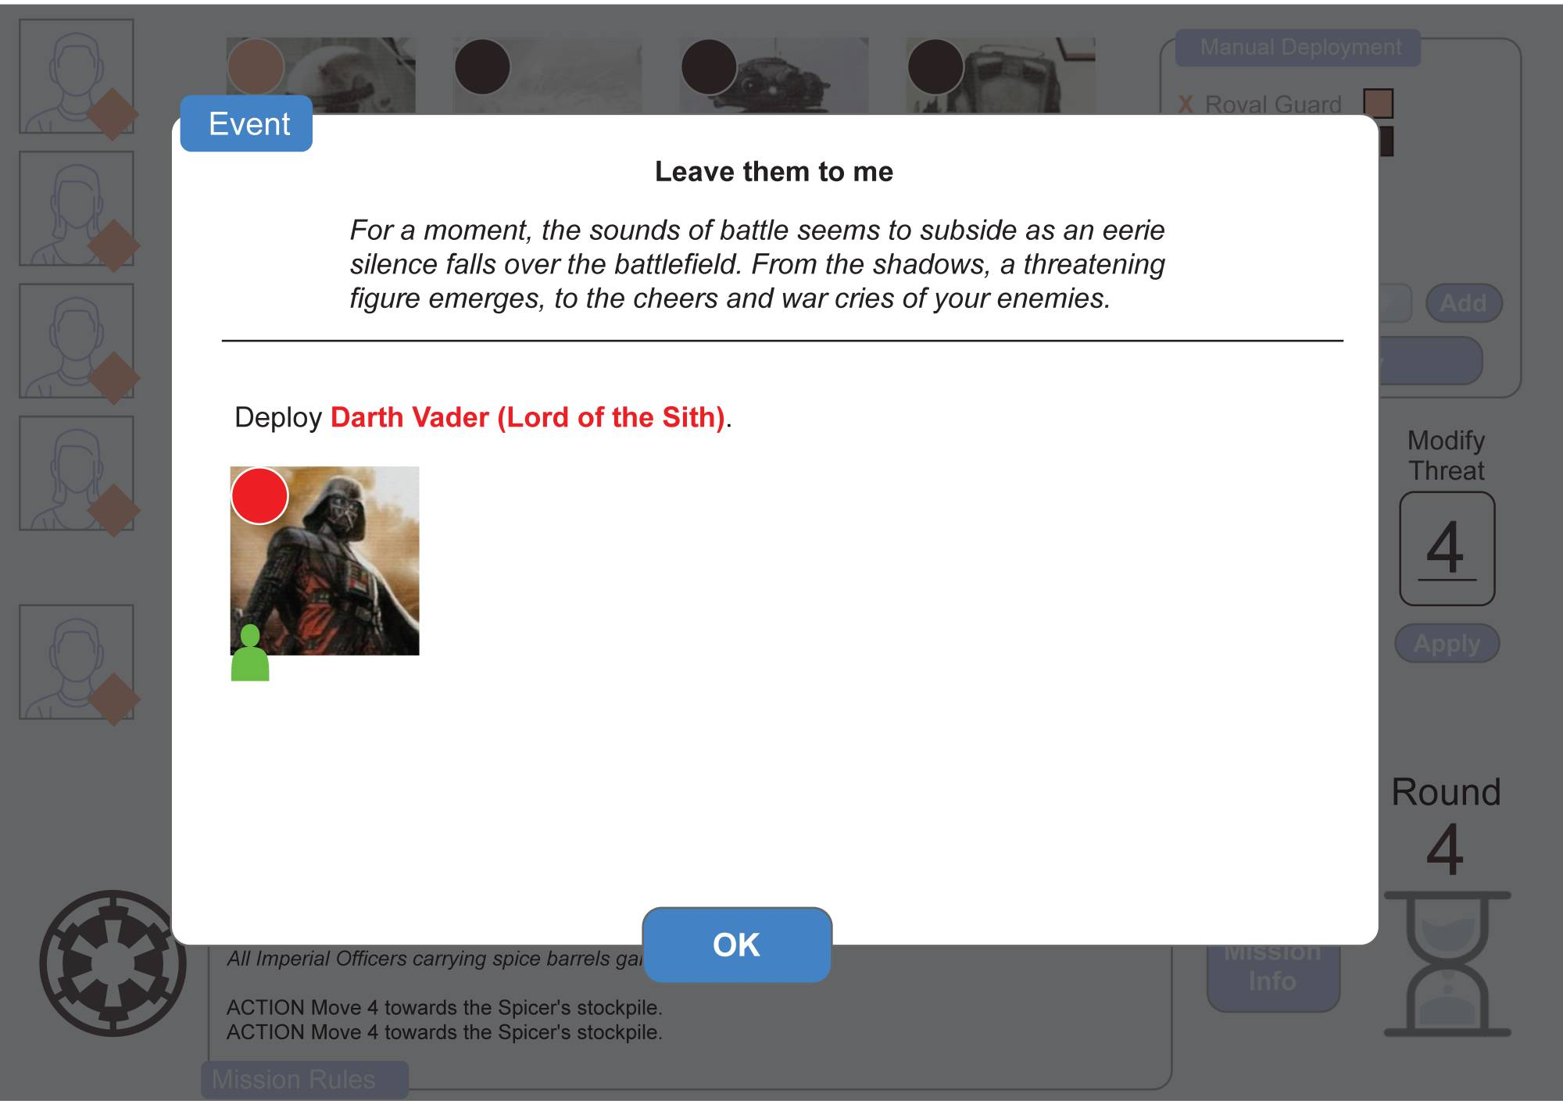

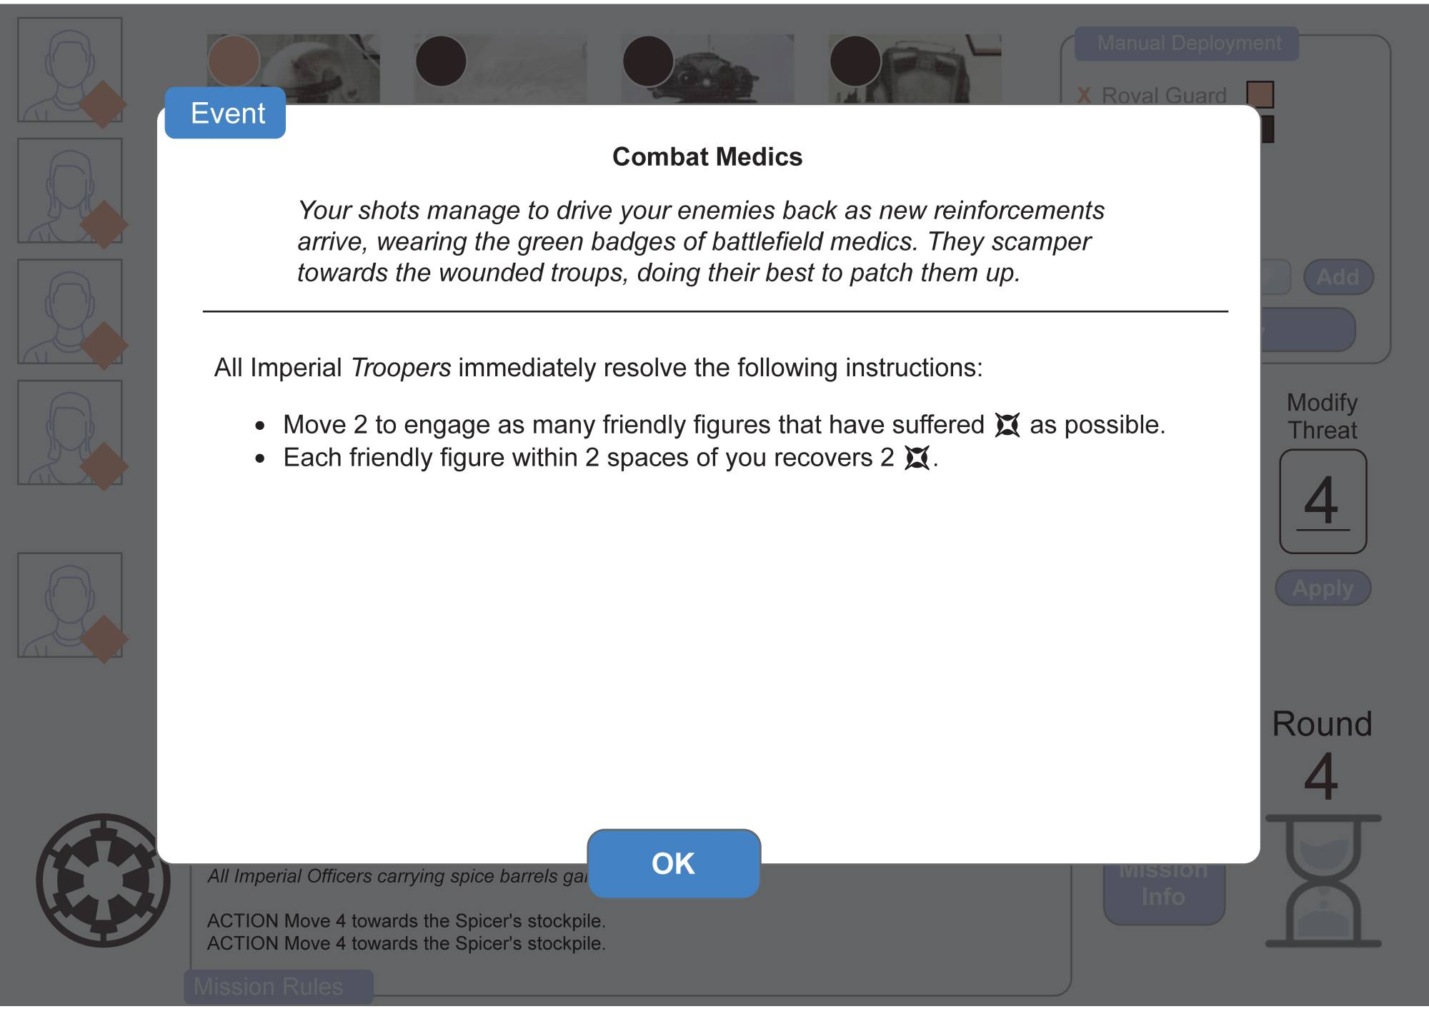

Events can happen between rounds, right after the deployment. Each round, there’s a small chance for an event to happen. No more than 2 or 3 events are allowed per mission.

Events are usually just instructions for players to follow, but some of them may deploy or defeat groups.

## Difficulty options

* **Easy:** Threat increase x 0.7. Any time an Elite group is deployed, it has a 15 % chance to be downgraded to a normal group without refunding of threat. (If the respective normal group is still available.) At each activation, there’s a 25 % chance that no bonus effect will be applied.
* **Medium:** No change.
* **Hard:** Threat increase x1.3 Any time a normal group is deployed, it has a 15 % chance to be upgraded to an Elite group at no additional threat cost. (If the respective normal group is still available.) Deployment Modifier starts at 2 instead of 0.

## Creating the deployment hand

When a mission is started, the app performs the following steps to create the deployment hand:

1. Gather all deployment groups available, determined by the selected factions and expansions. Deployment groups are separated into three tiers, based on their threat cost (low cost, medium cost, high cost).
2. Remove all Starting, Reserved, and Ignored groups.
3. Add any earned villains.
4. Create the deployment hand by drawing a number of groups based on threat level:

|  |  |  |  |  |
| --- | --- | --- | --- | --- |
| **Threat Level** | **Tier I** | **Tier II** | **Tier III** | **Total** |
| 2 | 2 | 2 | 0 | 4 |
| 3 | 2 | 2 | 0 | 4 |
| 4 | 1 | 2 | 1 | 4 |
| 5 | 1 | 2 | 2 | 5 |
| 6+ | 1 | 2 | 2 | 5 |

1. The resulting cards form the deployment hands. All other groups are discarded for the mission. They can only be deployed manually during a mission.

## Deployment rules

When the round ends, there are 4 possible options for deployment behavior. At the start of deployment, the app rolls 2D6. It then applies the “Deployment Modifier”. The DM starts at 0 and changes each round, depending on the behavior.

|  |  |  |
| --- | --- | --- |
| **2D6+DM** | **Behavior** | **Description** |
| -2-4 | Calm | * Threat +Threat Level * No deployment * DM +2 |
| 5-7 | Reinforcements | * Threat +Threat Level * Reinforce up to 2 groups * DM +1 |
| 8-10 | Landing | * Threat +Threat Level +1 * Deploy up to 2 new groups * “Fuzzy deployment” (see below) * DM +1 |
| 11+ | Onslaught | * Threat +Threat Level +2 * Reinforce up to 2 groups (cost decreased by 1, to a minimum of 1) * Deploy as many new groups as possible, decreased cost:   + Tier I: no change   + Tier II: cost -1   + Tier III: cost -2 * “Fuzzy deployment” (see below) * DM = -2 |

### Fuzzy deployment

If the app chooses to deploy a Tier III (=expensive) group, but does not have enough threat by up to 3 points, it still deploys the unit and reduces threat to 0. This way, the deployment of expensive units does not hinge on a tiny amount of missing threat, but doesn’t simply make them cheaper.

***Example:*** The app chooses to deploy an AT-ST (threat cost 14). It can deploy even if there is only 11, 12, or 13 threat left.

## Manual Deployment

Players can perform a manual deployment in the app. Manual deployment instructs the app to add a specific enemy or ally group to the list of groups. This can, for example, be used for deploying reserved groups or allies that are deployed by mission events.

Manually deployed groups act as normal. Once such a group is deployed, there is no distinction between it and any other group. Allies are controlled by the players. Manually deployed enemy groups are activated by the app. Once such a (non-unique) group is defeated, it returns to the deployment hand and can be re-deployed in future rounds.

* Manual deployment does not affect threat: A manually deployed group does not cost threat, not does a manually deployed ally increase threat.
* When a manual deployment is performed, the app first uses groups NOT in the deployment hand, but from among the rest of the available groups. If no such group is available, it uses groups from the deployment hand. If no such groups are available from the deployment hand, such a group cannot be manually deployed.

## Custom Deployment Group

The group list features a “Custom Group”. The custom group is used for specific mission groups, usually represented only by tokens (for example the X-8 droids in “Test of Metal”).

* A custom group always has a group size of 1 and no threat cost.
* It is never included in any deployment hand – it can only be deployed manually.
* A custom group’s instruction is always “See Mission Rules”.
* Once a custom group is defeated, it is removed from the mission, not returned to the deployment hand. To re-deploy it, it has to be deployed manually.

## Imperial Activations

When the players click on the icon to activate the next Imperial group, the app randomly chooses one non-exhausted group to activate and display the instructions. Afterwards, the group is exhausted (greyed out) and cannot be activated again until the next round.

### Activation Priority (Optional)

Enemy groups are given an activation priority (1 and 2). Priority-1-groups are more likely to be activated early than Priority-2-groups.

* If there are both Priority-1- and Priority-2-groups available, the app has a 70 % chance to activate a Priority-1-group first. This is enough to make sure they tend to be activated earlier, but not enough to be completely certain.

(This is optional. If it’s too much of a hassle to program, activations can easily be completely random.)

### Random Elements

Activating a group displays its activation instructions based on what group it is and whether it is a regular or an elite group. However, there are some random elements when a group is activated.

* The app randomly selects one of various bonus effects available to the group.
* The app randomly selects one healthy rebel figure as a target.
* Some groups have multiple instruction lists available. The app randomly selects which one to choose.

### Manual activations

Players can manually activate a group by clicking on it and confirming the activation. If they do, the group activates as normal and is exhausted afterwards.